
IMPLEMENT A TRAFFIC LIGHT CONTROLLER USING
FSM LAB # 12

Spring 2024

CSE-308L

Digital System Design Lab

Submitted by: Naveed Ahmad Registration No.: 22PWCSE2165
Class Section: B

“I affirm that I have completed this work with integrity”

Student Signature:

Submitted to:

Engr. Shah Zada Fahim Jan
Sunday, June 1, 2025

Department of Computer Systems Engineering University of Engineering and Technology, Peshawar

Implement A Traffic Light Controller Using FSM

Objectives:
- Continue the introduction to FSMs
- Mealy machine

Lab Tasks:




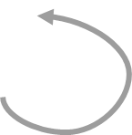

Task 1:
HG_FR
V = 1
HR_FY
H=001 F=100
H=100 F=010
D = 3 sec
D = 3 sec
HY_FR
HR_FG
H=010 F=100
D = 10 sec
H=100 F=001

V = 0
D < 3 sec

D < 3sec
D < 10 sec

Verilog Code:
module Traffic_lights(clk,rst,v,out_farm,out_highway); input clk,rst,v;
output reg [2:0] out_farm, out_highway; reg [1:0] PS,NS;
parameter [1:0] FR_HG = 0, FY_HR = 1, FG_HR = 2, FR_HY = 3;
parameter [2:0] red = 100, yellow = 010, green = 001; wire out_clk;
clk_divider d1(clk,out_clk,rst); always @(posedge out_clk)
if(rst==0) begin
PS = FR_HG;

end else

PS = NS;
always @(PS or v or rst) case(PS)

FR_HG:
begin

end
NS = v?FY_HR: FR_HG;
out_highway = v?red:green; out_farm = v?yellow:red;

FY_HR:
begin

end

NS = FG_HR;
out_highway = red; out_farm = green;

FG_HR:
begin

end

NS = FR_HY;
out_highway = yellow; out_farm = red;

FR_HY:
begin

endmodule

end endcase

NS = FR_HG;
out_highway = green; out_farm = red;

Clock Divider Code:
module clk_divider(input in_clk,output reg out_clk, input rst); reg [100:0] count;
always @(posedge in_clk) if(rst==0)
begin

end else begin
out_clk = 0;
count = 0;

count = count+1; if(count==3*100000000) begin

endmodule

end

end
out_clk = ~out_clk; count = 0;

UCF File:

UCF file:
net "rst" LOC =K18 | IOSTANDARD = LVCMOS33 | DRIVE = 8 | SLEW = FAST
| PULLUP;
net "v" LOC =F17 | IOSTANDARD = LVCMOS33 | DRIVE = 8 | SLEW = FAST | PULLUP;
net "clk" LOC =V10 | IOSTANDARD = LVCMOS33 | period = 100MHz;

net "out_highway[0]" LOC = N16 | IOSTANDARD = LVCMOS33 | DRIVE = 8 | SLEW = FAST;
net "out_highway[1]" LOC = U17 | IOSTANDARD = LVCMOS33 | DRIVE = 8 | SLEW = FAST;
net "out_highway[2]" LOC = U18 | IOSTANDARD = LVCMOS33 | DRIVE = 8 | SLEW = FAST;
net "out_farm[0]" LOC = P15 | IOSTANDARD = LVCMOS33 | DRIVE = 8 | SLEW = FAST;
net "out_farm[1]" LOC = P16 | IOSTANDARD = LVCMOS33 | DRIVE = 8 | SLEW = FAST;
net "out_farm[2]" LOC = N15 | IOSTANDARD = LVCMOS33 | DRIVE = 8 | SLEW = FAST;

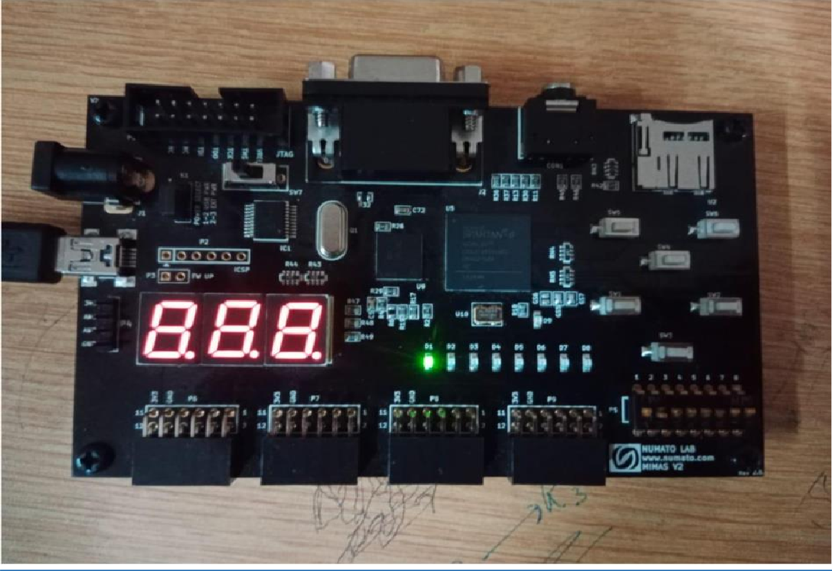
Output:

References:
- To view my lab codes, please refer to the DCSE repository on my GitHub Account: https://github.com/aimalexe/DCSE/tree/main/semester_6_(spring- 24)/digital_system_design_lab/lab_reports
- And so on…
- ​

Conclusion:
In summary, our Digital Systems Design lab has been a success, enabling us to achieve our objectives through hands-on tasks and theoretical exploration. This experience has enhanced my understanding of fundamental concepts in Verilog and their practical applications. I am excited to apply this knowledge in various contexts moving forward.

The End.

